ÀREA: VISUALS I PLÀSTICA
TOPIC: BODY PROPORTIONS

This worksheet is based on the following website:
http://www.worsleyschool.net/socialarts/body/proportions.html

STUDENT’S WORKSHEET

Read the following information and complete the chart at the bottom with the correct data.

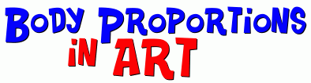
Artists have known for centuries that the average human adult body is made from parts that are in proportion to each other in predictable ways. If you draw your figures according to these ratios, your finished work will look more natural.
Body Proportions  At the right is a photograph with some of these common proportions shown. We should emphasize that these are averages, and will not necessarily hold true for every adult. In fact, what makes humans unique is that they come in a variety of shapes and sizes!  However, if you want your sketches and drawings to look natural, using these ratios will help.  The head width is used as a guide to shoulder width, which should be about three head widths.  All of the other measurements are based on head height:  - The average adult is seven heads tall.  - The top of the hips are four heads high.  - The pelvic region is about one head high.  - Elbow to fingertip is about two head lengths.  - Wrist to fingertip is one head length.  Leonardo da Vinci also used these ideal measurements when he was sketching the human figure. The drawing by da Vinci entitled 'Vitruvian Man' is based on a model of ideal proportions established by the ancient Roman Vitruvius. | 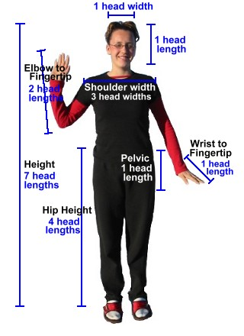

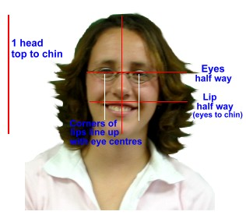 | Facial Proportions  Here is a list of standard facial proportions that can give you a good idea of what is 'average'.  - The eyes are halfway between the top of the head and the chin.  - The upper lip top is halfway between the eyes and the chin.  - The corners of the mouth line up with the centres of the eyes.  - The top of the ears line up on the eyebrows.  - The bottom of the ears line up with the bottom of the nose.  Remember, these are average values. Very few faces will follow every one of these ratios exactly, but if you make your sketches agree with them, you will get pleasing results.

Body and Face Proportions
BODY:
Adult body height: _ _ _ _ _ heads high
_ _ _ _ _ from shoulder to shoulder: 3 heads
Distance from the _ _ _ to toes: 4 heads
Distance from top of head to the bottom of chest: _ _ _ heads
Distance from _ _ _ _ _ to end of outstretched fingers: 1 head
_ _ _ _ _ _ height: 1 head
Distance from _ _ _ _ _ to end of outstretched fingers: 2 heads
FACE:
_ _ _ _ are halfway between top of the _ _ _ _ and chin
Upper _ _ _ is halfway between eyes and _ _ _ _
Corners of mouth line up with _ _ _ _ _ _ _ of eyes
Top of ears line up above the _ _ _ _, on eyebrows
Bottom of ears line up with bottom of _ _ _ _

Too difficult? See the solution.

